**User Stories**

We would thinking to make airlines app. In this app user can search their flights according to airport code form where they want to go. User can also search by date. User can also book their hotel information. We will use goibibo api search key for getting all flights information.

After getting whole flights data user can click on any flight and they can see detail information about flight. They can add it to our local database table(Trip table) with their flight info.

We are also going to work on User authentication with each user profile. In this phase user can see their own flight information and they can also update their flight info like dates of flights and airport location using airport code. And also delete their flight information.

**Wireframes:**

Home Page:

User can search on this page with their airport code from where they want to go. There is also some other information that user has to search like dates, flight, class, etc.

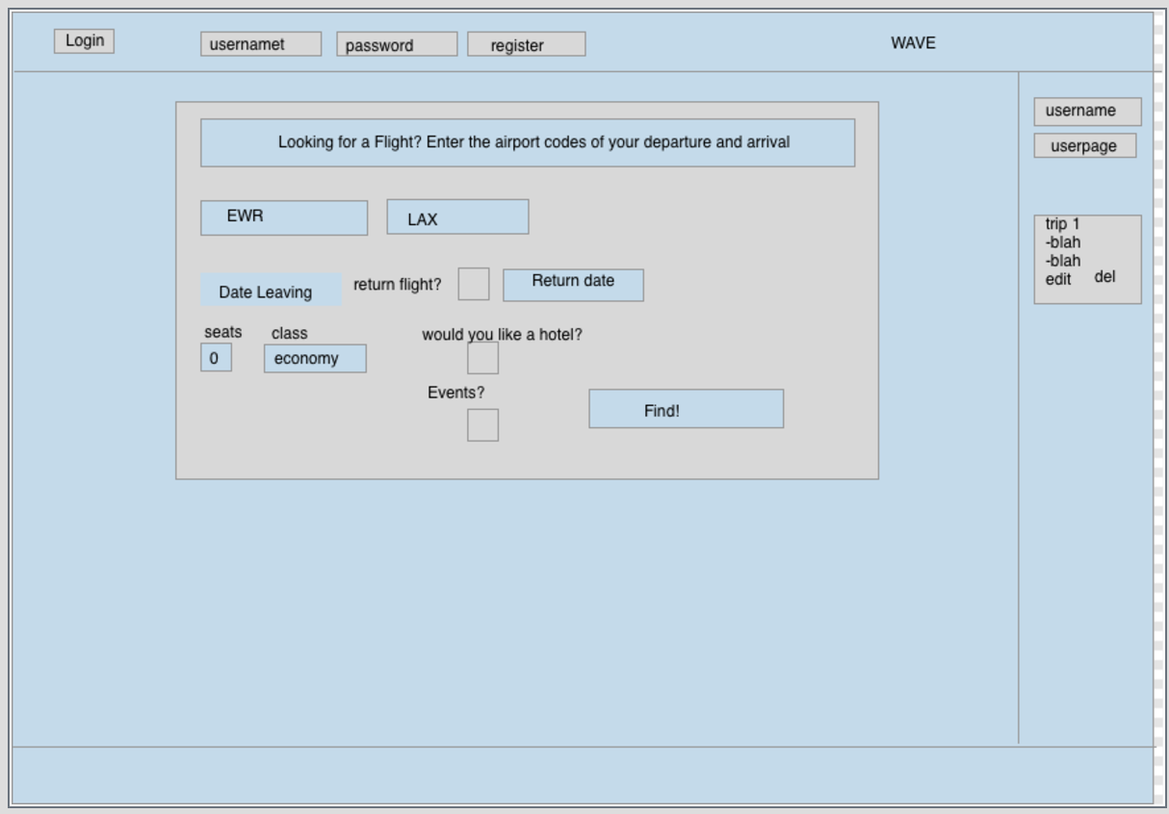

Hotel Select Page:

User can search city by name and they get all information about hotels.

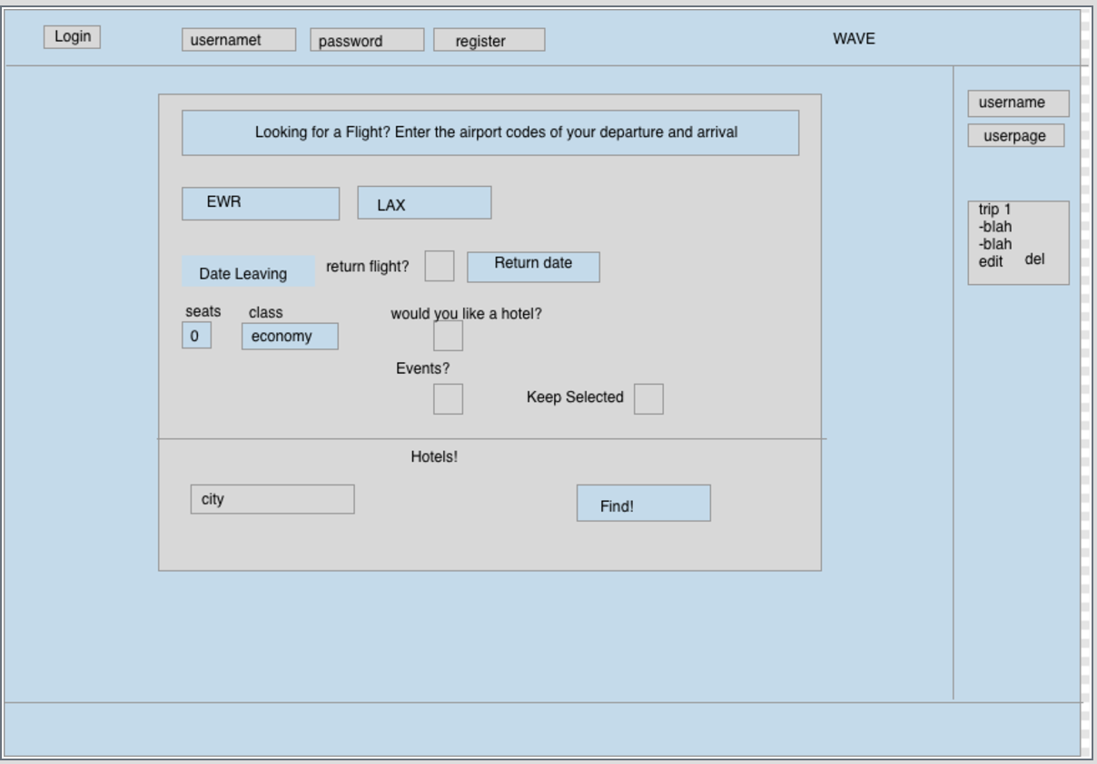

User Login Page:

User have to login to access their accounts to see all flight information.

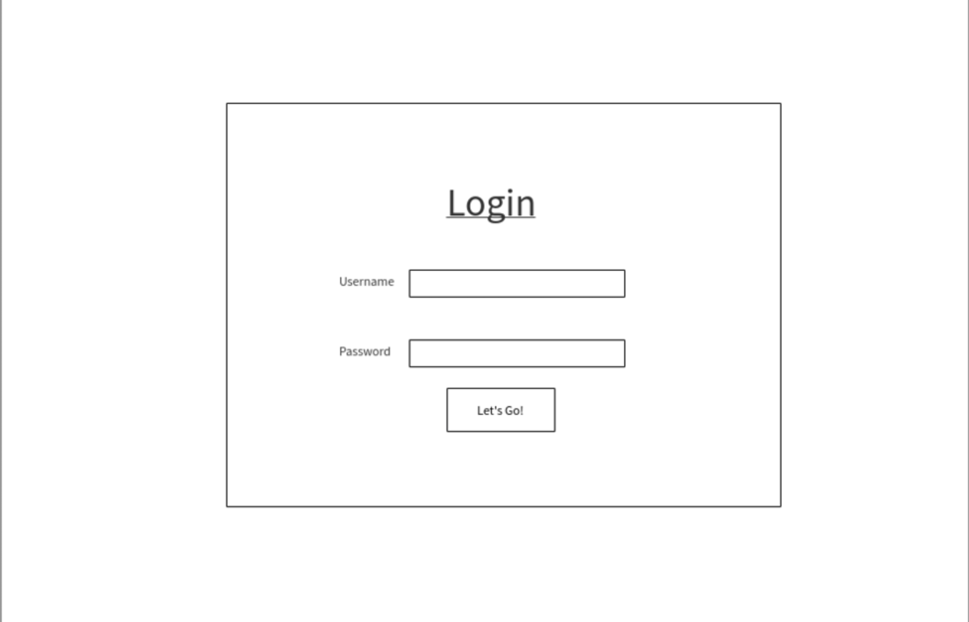

User Profile Page:

User can do update and delete functionality in this page according to their data.

